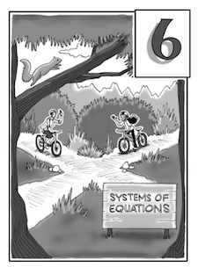

Chapter 6 Systems of Equations
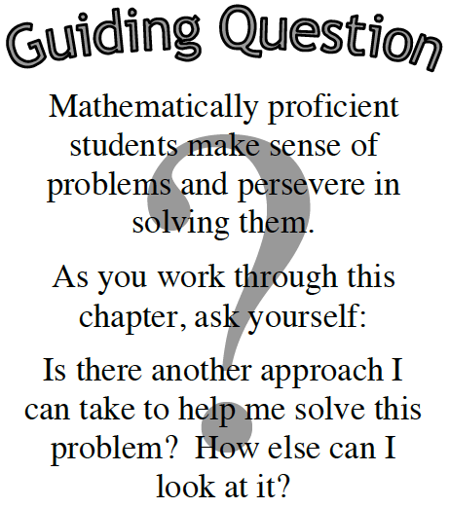
In Chapter 2, you studied the connections between the multiple representations of linear equations and learned how to write equations from situations. In this chapter, you will learn how to solve word problems by writing a pair of equations, called a system of equations. Then you will solve the system of equations using three different methods.

Along the way, you will develop ways to solve systems with equations written in different forms, and will learn how to recognize when one method may be more efficient than another. By the end of this chapter, you will know multiple ways to solve systems of equations that arise from different situations.

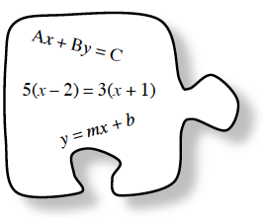 | Section 6.1 | In this section, you will solve multi-variable equations for one variable. You will write mathematical sentences (equations) in preparation for solving situational word problems.
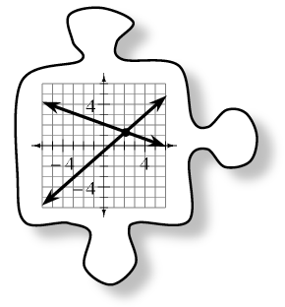 | Section 6.2 | In this section, you will learn two of the three algebraic methods for solving a system of equations: the Equal Values and Substitution Methods.
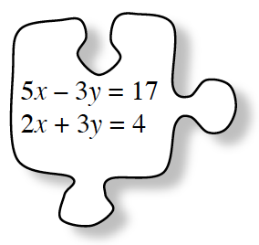 | Section 6.3 | You will continue to develop methods to solve systems of equations in different forms using the Elimination Method. You will learn what it means for a system to have no solution or infinite solutions.
 | Section 6.4 | Section 6.4 provides an opportunity for you to review and extend what you learned in previous chapters. You will also find ways to know which solving method is most efficient. You will make important connections among solving equations, multiple representations, and systems of equations.

- 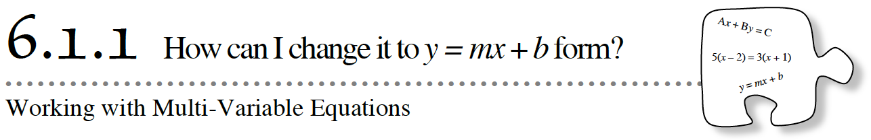
- You now have a lot of experience working with equations that compare two quantities. Today, you will apply your equation-solving skills to rewrite equations with two or more variables.

- 6-1. Georgia joined the Big Race. Her race can be modeled with the equation y = 3x + 4 where x is time (seconds) and y is distance (meters).
  - How much of a head start did Georgia get? How can you tell from the equation?
  - What was Georgia’s rate of speed? That is, how fast did she go? Justify your answer.

6-2. CHANGING FORMS
You could find the slope and y-intercept of the line y = 3x + 4 quickly because the equation was in y = mx + b form. But what if the equation is in a different form? Explore this situation below.
  - The linear equation –6x + 2y = 10 is written in standard form. Can you easily tell what the slope of the line is? The y-intercept? Predict these values.

  - Make a table and graph the line. Using your graph, write an equivalent equation of the line.

  - Now use algebraic steps to rewrite the equation –6x + 2y = 10 in y = form. Does your new equation match your graph from part (b)?

6-3. Your teacher will assign you one of the linear equations listed below. For your equation:

- Use algebraic steps to rewrite the equation in “y =” form. Be sure to record all of your work and be prepared to share your steps with the class.
- What is the slope of your line? What is the y-intercept? How can you tell?
- Choose one point on your line that is not an intercept and check it in both the original equation and your equivalent y = mx + b equation. Does it make both equations true?​

a. | - 2x + y = 3x – 7 | b. | - x + 2y = 3x + 4
c. | - 3y + 2 = 2y – 5x | d. | - 2(y – 3) = 2x – 6
e. | - 5 – 3(x + 1) = 2y – 3x + 2 | f. | - x – (y + 2) = 2(2x + 1)

- 6-4. In this problem, you will explore the graphical representation of solutions to equations.

  - How many variables does the equation 0 = 3x – 5 have? How many solutions does the equation 0 = 3x – 5 have? Use a number line to show the solution(s) graphically.

  - How many variables does the equation y = 3x – 5 have? How many solutions does the equation y = 3x – 5 have? How could you show the solution(s) graphically?

  - The graph of y = 0.2x³ – 5 is shown at below. How many solutions does y = 0.2x³ – 5 have? Explain.
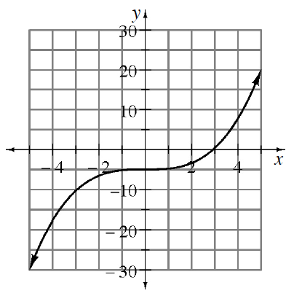

  - By looking at the graph, does it appear that (5, 8) is a solution to y = 0.2x³ – 5?

  - Explain how you could use the graph to estimate the solution to 4 = 0.2x³ – 5.

6-5. Often in everyday situations, a formula with more than one variable may not be in the form you need. The previous problem showed that linear equations not in y = mx + b form do not reveal the slope and y-intercept until they are solved for y, that is, written in y = form.
- The formulas in this problem are used in many different careers. Sometimes you need to solve them for a different variable in order for the formula to be useful.
- Solve each formula for the given variable.
a. | - W = Fd. What is the force, F, needed to move a piano given the amount of work applied, W, and distance moved, d ? | 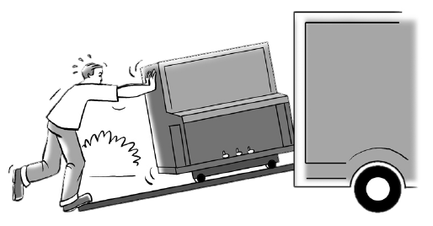
b. | F = 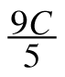 + 32. What is the temperature in Celsius, C, when given the temperature in degrees Fahrenheit, F?
c. | = 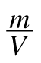. The symbol is a letter of the Greek alphabet called rho. Sometimes scientists use Greek letters for variables. What is the mass, m, of a precious stone given its density, , and volume, V?

- 6-6. Solve each of the following equations for the indicated variable. Be sure to record your work.
Solve for y: Solve for t: d = (r + c)t

Solve for y: x² + 4y = (x + 6)(x – 2) Solve for x: 3(2x + 4) = 2 + 6x + 10

- 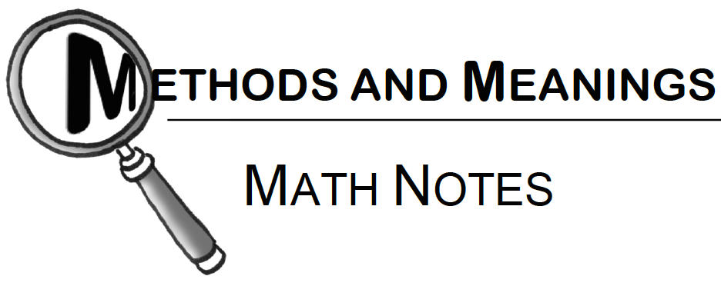 | Forms of a Linear Function  - There are three main forms of a linear function: slope-intercept form, standard form, and point-slope form. Study the examples below.
- Slope-Intercept form: y = mx + b. The slope is m, and the y-intercept is (0, b).

- Standard form: ax + by = c

- Point-Slope form: y – k = m (x – h). The slope is m, and (h, k) is a point on the line. For example, if the slope is –7 and the point (20, –10) is on the line, the equation of the line can be written y – (–10) = –7(x – 20) or y + 10 = –7(x – 20).

HOMEWORK ASSIGNMENT
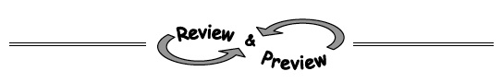
Name________________________Per______

6-7. Solve each equation for the indicated variable.

  - 3x − 2y = 18 for x b. 3x − 2y = 18 for y c. C = 2πr for r

6-8. Complete the area models below.
Then write the area of each rectangle as a product equivalent to a sum.
- a. | - 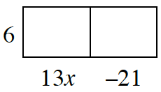 | - b. | - 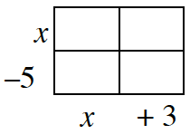
- c. | - 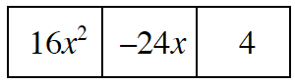 | - d. | - 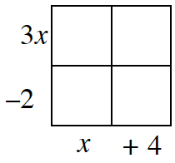

6-9. A researcher wanted to see if there was an association between the number of hours spent watching TV and students’ grade point averages. He found r = –0.72. Interpret the researcher’s results.

6-10. Given the sequence 7, 11, 15, 19, ….
  - What kind of sequence is it?
  - Write an explicit equation for the sequence.
  - Is 109 a term of the sequence? If so, which term is it?

6-11. Camila is trying to determine the equation of a line that passes through the points (–1, 16) and (5, 88). Does the function f(x) = 12x + 28 work? Justify your answer.

6-12. Solve this problem by writing and solving an equation. Be sure to define your variable.

- a. A rectangle has a perimeter of 30 inches. Its length is one less than three times its width. What are the length and the width of the rectangle?

b. Does your answer make sense in this context?

- 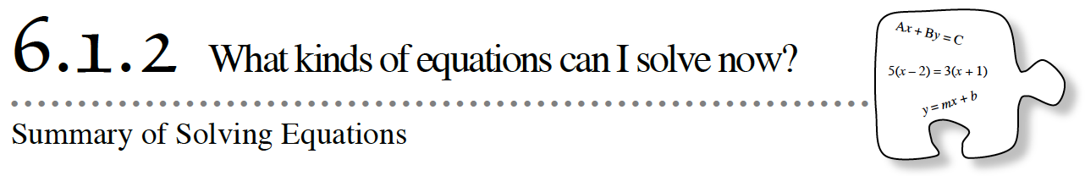
- Throughout this course you have been developing your algebraic solving skills. Today, you will practice solving several types of equations. You will conclude by summarizing everything you know about solving equations.

- 6-13. As you solve the equations below, be sure to record all of your steps carefully. Check your solutions, if possible.

- Solve for h: | - Solve for x: x(2x − 1) = 2x² + 5x − 12
- Solve for y: 3x + 6y = 24 | - Solve for x: 2 − 3(2x − 1) = −6x + 5
- Solve for x: 2(5x + z) = 30x + 3y + 10 | - Solve for x: 4x(x + 1) = (2x − 3)(2x + 5)
- Solve for x: 5(−3 + x) = 35 | - Solve for m:
- Solve for b: ab − 2 = 3c | - Solve for w: 2(v − 3) = 1 − (w + 4)

- 6-14. LEARNING LOG
- In your Learning Log, write a letter to a new student in class explaining everything you know about solving equations. Provide examples that show all of the different equation-solving skills you have. Be sure to explain your ideas thoroughly so your classmate will know what to do on his or her own. Title this entry “Solving Equations” and include today’s date.

HOMEWORK ASSIGNMENT
Name________________________Per______
6-15. Solve for y.
  - 8x + 4y = 2 b. 12x – 3y = 7

6-16. Solve each equation for the variable. Check your solutions, if possible.
- 8a + a − 3 = 6a − 2a – 3 b. (m + 2)(m + 3) = (m + 2)(m − 2)

c. 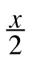 + 1 = 6 d. 4t − 2 + t² = 6 + t²

6-17. Aura currently pays $800 each month to rent her apartment. Due to inflation, however, her rent is increasing by $50 each year. Meanwhile, her monthly take-home pay is $1500 and she predicts that her monthly pay will only increase by $15 each year. Assuming that her rent and take-home pay will continue to grow linearly, will her rent ever equal her take-home pay? If so, when? And how much will rent be that year?

6-18. What is the missing term in each sequence?
- a. | - 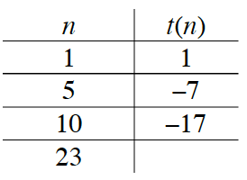  - Hint: This is an arithmetic sequence. | - b. | - 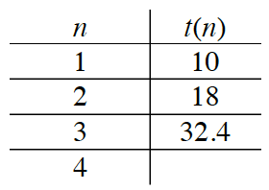
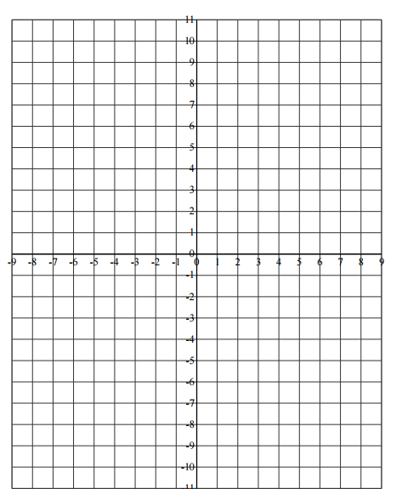
6-19. On graph paper, plot and connect the points to form trapezoid WXYZ if its vertices are W(7, 3), X(4, 3), Y(1, 9), and Z(6, 5). Remember that a trapezoid is a 4-sided figure (quadrilateral) with at least one pair of parallel sides.
  - If WXYZ is reflected using the transformation function (x → −x, y → y) to form W′X′Y′Z′, then where is Y′?
  - Name a sequence of at least two rigid transformations that will take W′X′Y′Z′ back on to WXYZ.

6-20. Graph the lines y = x + 2 and y = 2x − 1 on the same set of axes. What is their point of intersection?

- 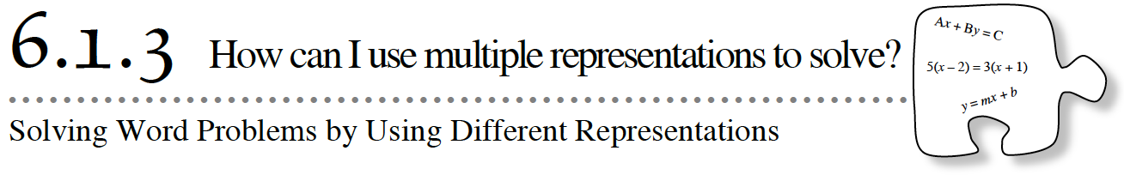
- Today you will explore using multiple representations to solve a word problem.

6-21. PLANTING TREES
- Charles and Amy are summer interns at a state park. They are helping to plant trees in an area where there was a forest fire. Charles’s uncle owns a tree nursery and is willing to donate a 3 foot tall tree that will grow 1.5 feet per year.

- Amy goes to another nursery, but is only able to get tree seeds donated. According to the seed package, the trees will grow 1.75 feet per year.

- Charles plants the tree and Amy plants a seed on the same day. Amy thinks that even though her tree will be much shorter than Charles’s tree for the first several years, it will eventually be taller because it grows more each year, but she does not know how many years it will take for her tree to grow as tall as Charles’s tree.

- Will the trees ever be the same size? If so, how many years will it take?

- Your Task: Use three representations (table, graph, equation) to justify your solution.

- 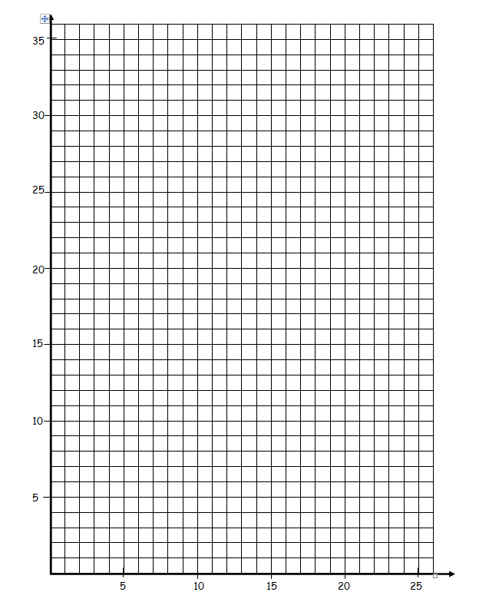
6-22. Explore the meaning of solutions to the Planting Trees problem by answering these questions:

  - How many solutions does the equation for Charles’s tree have? That is, how many coordinate pairs make the equation true? How many solutions does the equation for Amy’s tree have?

  - In the context of the Planting Trees situation, what is the meaning of a solution to Charles’s equation?

  - How many (x, y) coordinate pairs are solutions to both Charles’s and Amy’s equations? How can you tell by looking at a graph?

6-23. Two of the park rangers also want to help restore the forest after the fire. They plant trees that have been bred to grow as follows:
Years | Ranger Zhu’s Tree | Ranger Torres’s Tree
2 | 8 ft | 6 ft
4 | 11 ft | 9 ft
6 | 14 ft | 12 ft

  - Write an equation for both Ranger Zhu’s tree and Ranger Torres’s tree. Graph both lines the graph from the previous page.
  - When will Ranger Zhu’s tree be the same height as Charles’s tree? When will Ranger Torres’s tree be the same height as Charles’s tree?

  - You could have answered part (b) by simply looking at the equations for Ranger Zhu’s and Ranger Torres’s trees. Explain how you could answer the questions before you graphed.

6-24. In the Planting Trees problem earlier in this lesson, you wrote equations that were models of an everyday situation. Models are usually not perfect representations, but they are useful for describing everyday behavior and for making predictions. You predicted when the two trees would be the same height.
  - Your linear model made certain assumptions about tree growth. What are some of the assumptions of this model?

  - What are an appropriate domain and range for the models of the growth of Charles’s and Amy’s trees?

HOMEWORK ASSIGNMENT
Name________________________Per______

6-25. As Sally and George practice for the SAT, their scores on practice tests rise. Sally’s current score is 850, and it is rising by 10 points per week. On the other hand, George’s current score is 570 and is growing by 50 points per week.

  - When will George’s score catch up to Sally’s?

  - If the SAT test is in 12 weeks, who will score highest?

6-26. Solve for x. Check your solutions, if possible. Graph your solutions on a number line.

  - −2(4 − 3x) − 6x = 10 b. 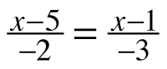

6-27. On the same set of axes, graph each line in the system shown below. What is the point of intersection? Does more than one exist? How do you know for sure?
- y = −x + 2
- y = 3x + 6

6-28. Suppose you found that the correlation between the life expectancy of citizens in a nation and the average number of TVs in households in that nation is r = 0.89. Does that mean that watching TV helps you live longer?

6-29. For each recursively-defined sequence below, write the first few terms. Then use the terms to write an explicit equation.

a. a₁ = 17, a_{n+1} = a_{n} – 3 b. a₁ = 20, a_{n+1} = · a_{n}

6-30. Solve each equation below.

  - 4^{x} = 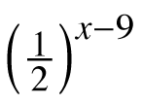 b. 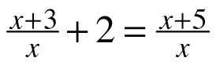

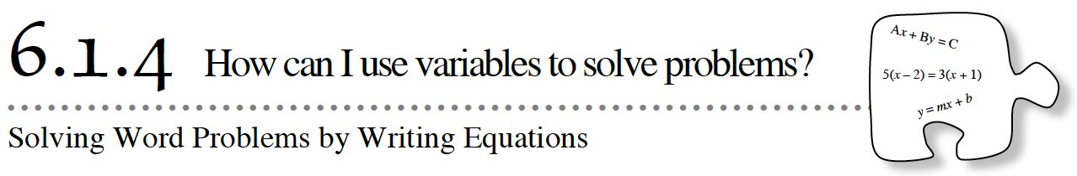

Today you will learn to translate written information into algebraic symbols and then solve the equations that represent the written relationships. You will also explore a relationship involving distance, rate, and time.

6-31. Match each mathematical sentence on the left with its translation on the right. Make sure your team is in agreement with each answer before moving on.

a.  b.  c.  d | 2z + 12 = 30  12z + 5(z + 2) = 30  z + (z - 2) + 5(z - 2) = 30  z + 12z = 30 | 1.  2.  3.  4. | A zoo has two fewer elephants than zebras and five times more monkeys than elephants. The total number of elephants, monkeys, and zebras is 30.  Zola earned $30 by working two hours and receiving a $12 bonus.  Thirty ounces of metal is created by mixing zinc with silver. The number of ounces of silver needed is twelve times the number of ounces of zinc.  Eddie, who earns $5 per hour, worked two hours longer than Zach, who earns $12 per hour. Together they earned $30.

6-32. Mathematical sentences, like those in the left column of problem 6-31, are easier to understand when everyone knows what the variables represent. A statement that describes what the variable represents is called a “let” statement. For example, for mathematical sentence (a) above, which is matched with translation 2, we could say, “Let z = Zola’s rate of pay (dollars/hour).” Note that a let statement always indicates the units of measurement.

- Write a let statement for each of the mathematical sentences in parts (b) through (d) of problem 6-31.
a. | b.
c. | d.

6-33. Defining your variables and writing your equations powerpoint
- Define your variables
- Set up two equations
Example: Tatiana spent $40 on candy and was able to buy 50 different items. Each chocolate cost $1 and each lollipop cost $0.50.
- Let c = number of chocolates and let p = number of lollipops
- 1c + 0.50p = 40 and c + p = 50

1. | 2.
3. | 4.
5. | 6.

6-34. Another situation
Elsie took all of her cans and bottles from home to the recycling center. The number of cans was one more than four times the number of bottles. She earned 12¢ for each bottle and 10¢ for each can, and ended up earning $2.18 in all.

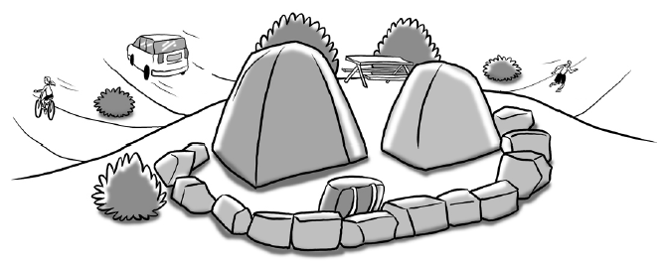
6-35. SUMMERTIME CAMPING!
- Morgan and her family are camping on their summer vacation.

  - Morgan decided to take a bike ride before it got too hot. She left the campsite and rode her bike at a speed of 16 miles per hour for 1.5 hours. How far did she bike?

  - Morgan’s dad went to get groceries at the campsite store at the bottom of the mountain. He drove 20 miles per hour for 0.4 hours. How far did he drive?

HOMEWORK ASSIGNMENT
- Name________________________Per______

6-38. The perimeter of a triangle is 31 cm. Sides #1 and #2 have equal length, while Side #3 is one centimeter shorter than twice the length of Side #1. Determine how long each side is by completing parts (a) through (c) below.

  - Let x represent the length of Side #1. What essential part of this let statement is missing? What is the length of Side #2? Side #3?

  - Write a mathematical sentence that states that the sums of the sides equals the perimeter, which is 31 cm.

  - Solve the equation you found in part (b) and determine the length of each side. Be sure to label your answers with the appropriate units.

6-39. The Earth travels 584 million miles in the one year it takes to go around the sun. If there are 365 days in a year, what speed does the Earth travel at in miles per day? What speed does the Earth travel at in miles per hour?

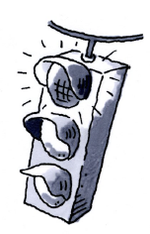
6-40. When Ms. Shreve solved an equation in class, she checked her solution and it did not make the equation true! Examine her work below and find her mistake. Then find the correct solution.

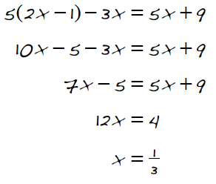

6-41. For the sequence 5, 25, 125, 625, …

  - What kind of sequence is it?

  - What is the fifth term, a₅?

  - Write an explicit equation for the sequence.

6-42. Multiple Choice: Which line below is perpendicular to

  - 2x − 3y = 6
  - 2x + 3y = 6
  - 3x − 2y = 6
  - 3x + 2y = 6

6-43. On graph paper, draw AC with coordinates A(2, 6) and C(5, −1). Then draw a slope triangle. Use the slope triangle to calculate the length of AC. Consider the precision of the measurement.

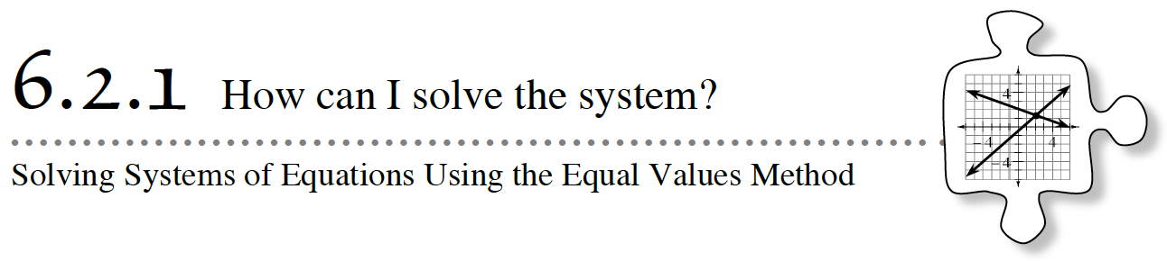
In previous lessons, you wrote systems of equations that represented situations given in word problems. Today you explore how to use the Equal Values Method to solve systems containing equations that are not in
y = mx + b form.

6-44. A set of two or more equations with the same variables is called a system of equations. When you set the two expressions that are equal to the same variable equal to each other, like you did in the previous lesson, you are using the Equal Values Method of solving a system of equations. Use the Equal Values Method to solve the following problem.

It is time to cool off on a hot summer day! Team Sunshine is filling an inflatable kiddie pool from a garden hose. The pool has 30 gallons in it and Team Sunshine is adding 8 gallons per minute with a garden hose.

Next door, Team Breeze’s pool is already filled with 180 gallons of water. They are emptying the pool at 5 gallons per minute with buckets.

Write two equations to represent the situation. Use the equations to find how long it takes until both pools have the same amount of water. Check your calculations.

- 6-45. THE TORTOISE AND THE HARE
- The tortoise and the hare are having a race. In this tale, the tortoise moves at 50 feet per hour while the hare moves at 250 feet per hour. The tortoise takes 8 hours longer than the hare to finish. What was the distance of the race?

  - Let t represent the unknown time in hours that it took the hare to complete the race. Write an expression (not an equation!) representing the time it took the tortoise to finish the race.

  - Write two equations that represent the race, one for the hare and one for the tortoise.

  - What is the distance of the race?

- 6-46. MIXING CANDY
- Renard thought that writing two equations for problem 6-44 was easy. He wants to use two equations with two variables to solve this problem:

- Ariel bought several bags of caramel candy and several bags of taffy. The number of bags of taffy was 5 more than the number of bags of caramels. Taffy bags weigh 8 ounces each, and caramel bags weigh 16 ounces each. The total weight of all the bags of candy was 400 ounces. How many bags of candy did she buy?

  - Renard lets t = the number of taffy bags and c = the number of caramel bags. Help him write two equations to represent the information in the problem.

  - Now Renard is stuck. He says, “If both of the equations were in the form ‘t = something’, I could set the two expressions equal to each other to find the solution.” Help him rewrite the equations into a form he can use to solve the problem.

  - Solve Renard’s system of equations to find the number of bags of caramel and number of bags of taffy that Ariel bought.

  - How you can verify that your solution is correct?

- 6-47. When you write equations to solve word problems, you sometimes end up with two equations like Renard’s or similar to the two equations below. Notice that the second equation is solved for y, but the first is not. Rewrite the first equation in “y =” form, then solve this system of equations. Check your solution.

- x − 2y = 4

- 6-48. Solve the system of equations below using the Equal Values Method. Check your solution.

- x + 2y = 14
- −x + 3y = 26

The Equal Values Method
The Equal Values Method is a method for solving a system of equations. For example, solve the system of equations at right. | 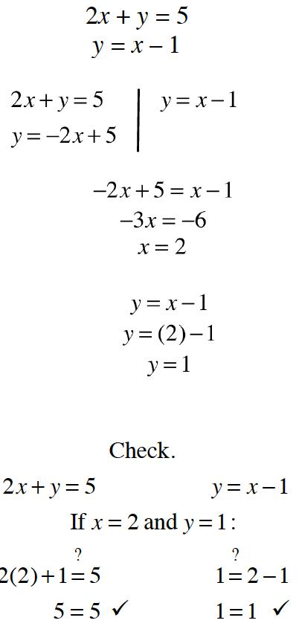
Write both equations in “y =” form.
Take the two expressions that equal y and set them equal to each other. Then solve this new equation to find x.
Once you know the value of x, substitute that value into either original equation to solve for y. In this example, the second equation is used.
Check your solution by substituting the values of x and y in both of the original equations.
The solution is x = 2 and y = 1.

- Name________________________Per______
HOMEWORK ASSIGNMENT

6-49. Write an equation to represent each of the situations described below.

  - On Friday, 150 people went to see “Ode to Algebra” performed in the school auditorium.
Both c children and a adults attended the performance.

  - The cost of a new CD is $14.95, and the cost of a video game is $39.99. Wade spent $84.84 on c CDs and v video games.

6-50. Jonathan and Laura are three miles apart and traveling towards each other. If Jonathan travels m miles, write an expression to represent how far Laura has traveled when they meet each other.

6-51. Solve each of the following equations for the indicated variable. Show all of your steps.

  - y = 2x − 5 for x b. p = −aw + 9 for w

c. 2m − 6 = 4n + 4 for m d. bx − y = −2y for y

6-52. The basketball coach at Washington High School normally starts each game with the following five players:
Melinda, Samantha, Carly, Allison, and Kendra

However, due to illness, she needs to substitute Barbara for Allison and Lakeisha for Melinda at this week’s game. What will be the starting roster for this upcoming game?

6-53. Sam took his savings to the bank and deposited them in a Certificate of Deposit (CD) account. He was told that he would collect the full interest in 260 weeks. How many years would Sam have to wait to collect the full interest? Show your work using dimensional analysis and Giant Ones. (There are 52 weeks in one year).

6-54. Write the first 5 terms for each of the sequences.

  - a_{n} = 2n – 5

  - a₁ = 3

  - a_{n+1} = –2 · a_{n}

6.2.1 Equal value method practice.
Solve each system of equations
* Remember all answers should be in coordinate form (x, y) *

1. | 2.
3. | 4.
5. | 6.
7. | 8.

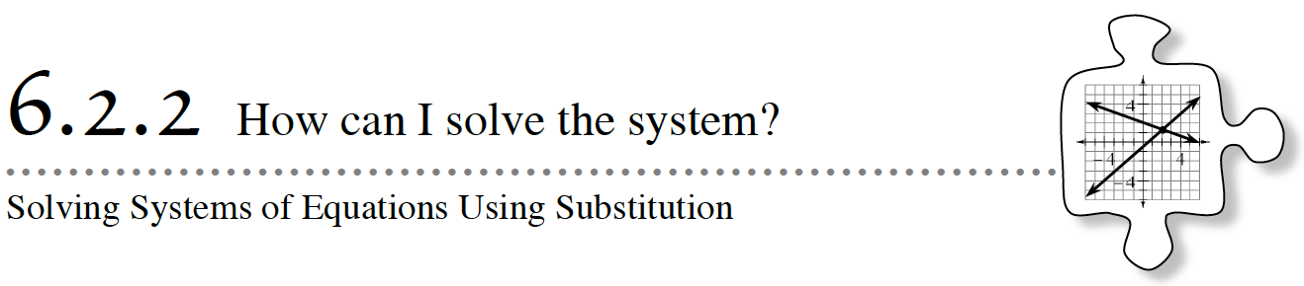
In Lesson 6.2.1, you helped Renard develop the Equal Values Method of solving a system of equations. You rewrote at least one of the equations so that both equations were in “y = ” form. Today you will develop a more efficient method of solving systems that are too messy to solve by using the Equal Values Method.

6-55. Review what you learned in Lesson 6.2.1 as you solve the system of equations below. Check your solution.
y = −x − 7
5y + 3x = −13

6-56. AVOIDING THE MESS
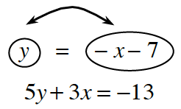
- A new method, called the Substitution Method, can help you solve the system in problem 6-55 without using fractions. This method is outlined below.

  - If y = −x − 7, then does −x − 7 = y? That is, can you switch the y and the −x − 7? Why or why not?

  - Since you know that y = −x − 7, can you replace the y in the second equation with −x − 7 from the top equation? Why or why not?
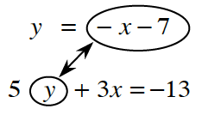
  - Once you replace the y in the second equation with – x – 7, you have an equation with only one variable, as shown below. This is called substitution because you are substituting for (replacing) y with an expression that it equals. Solve this new equation for x and then use that result to find y in either of the original equations.
- 5(−x − 7) + 3x = −13

6-57. Solve the system of equations
a) b)

6-58. When Mei solved the system of equations below, she got the solution x = 1, y = 6. Without solving the system yourself, can you tell her whether this solution is correct? How do you know?
- 4x + 3y = 22
- x − 2y = 0

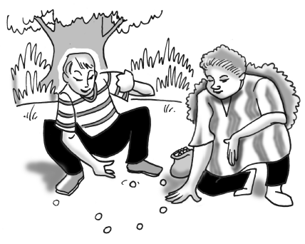
6-59. HAPPY BIRTHDAY!
- You have decided to give your best friend a bag of red and green marbles for his birthday. Your friend likes green marbles better than red ones, so the bag has twice as many green marbles as red. The label on the bag says it contains a total of 84 marbles.

- How many green marbles are in the bag? Write a system of equations for this problem. Then solve the problem using any method you like. Be sure to check your solution.

Name________________________Per______
1 . Bob climbed down a ladder from his roof, while Roy climbed up another ladder next to Bob’s ladder. Each ladder had 30 rungs. Their friend Jill recorded the following information about Bob and Roy:
HOMEWORK ASSIGNMENT

Bob went down two rungs every second.
Roy went up one rung every second.

- At some point, Bob and Roy were at the same height. Which rung were they on?

2. Solve for x.

  - 6x − 11 = 4x + 12 b. 2(3x −5) = 6x − 4

c. (x − 3)(x + 4) = x² + 4 d. 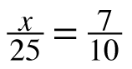

e. f. x + 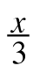 = 4

CL 6-149. Solve each equation for the indicated variable.

  - t = an + b (for b) b.

c. F = ma (for m) d. F = ma (for a)

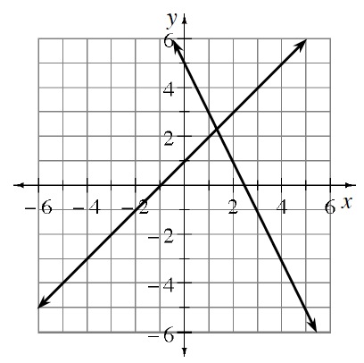
CL 6-150. Leo solved a system of equations by graphing. His graph is shown below.

  - Estimate the solution from the graph
  - What is the equation of each line in the system?
  - Solve the system algebraically. How accurate was your estimate?

CL 6-151. As treasurer of his school’s FFA club, Kenny wants to buy gifts for all 18 members. He can buy t-shirts for $9 and sweatshirts for $15. The club has only $180 to spend. If Kenny wants to spend all of the club’s money, how many of each type of gift can he buy?

Write a system of equations representing this problem.

6.2.2 Solving by Substitution Practice. Solve each system of equations
* Remember all answers should be in coordinate form (x, y) *

1. | 2.
3. | 4.
5. | 6.
7. | 8.
9. | 10.
11. | 12.

- Name________________________Per______
HOMEWORK ASSIGNMENT

6-61. The Fabulous Footballers scored an incredible 55 points during last night’s game. Interestingly, the number of field goals was one more than twice the number of touchdowns. The Fabulous Footballers earned seven points for each touchdown and three points for each field goal.

  - Multiple Choice: Which system of equations below best represents this situation? Explain your reasoning. Assume that t represents the number of touchdowns and f represents the number of field goals.

i. | t = 2f + 1  7t + 3f = 55 | ii. | f = 2t + 1  7t + 3f = 55
iii. | t = 2f + 1  3t + 7f = 55 | iv. | f = 2t + 1  3t + 7f = 55
  - Solve the system you selected in part (a) to determine how many touchdowns and field goals the Fabulous Footballers made last night.

6-62. Yesterday Mica was given some information and was asked to write a linear equation. But last night her cat destroyed most of the information! At right is all she has left:
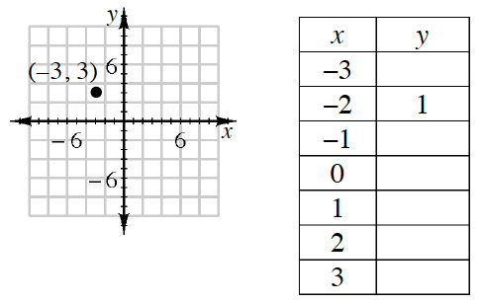
  - Complete the table and graph the line that represents Mica’s rule.

  - Mica thinks the equation for this graph could be 2x + y = −3. Is she correct? Explain why or why not. If not, write your own equation to match the graph and x → y table.

6-63. Given the sequence 2, 10, 50, 250, … complete parts (a) through (c) below.

  - What kind of sequence is it?

  - Describe the shape of the graph.

  - Write an explicit equation for the sequence.

6-64. Kevin and his little sister, Katy, are trying to solve the system of equations shown below. Kevin thinks that using the Substitution Method should give a new equation of 3(6x – 1) + 2y = 43, while Katy thinks it should be 3x + 2(6x − 1) = 43. Who is correct and why?

y = 6x − 1
3x + 2y = 43

6-65. Rewrite each expression. In parts (a) and (b), write your answers without negative exponents.
- In parts (c) and (d), write your answers in scientific notation.

  - 5⁰ · 2⁻³ b. 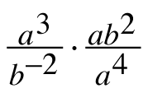

c. 2.3 × 10⁻³ · 4.2 × 10² d. (3.5 × 10³)²

6-66. Interpret each of the following effects on the function, f(x). For example, f(x + 2) indicates to “calculate the output for the input that is 2 greater than x.”

  - f(6w)

  - g(h − 2)

  - 4f(a) + 10

- 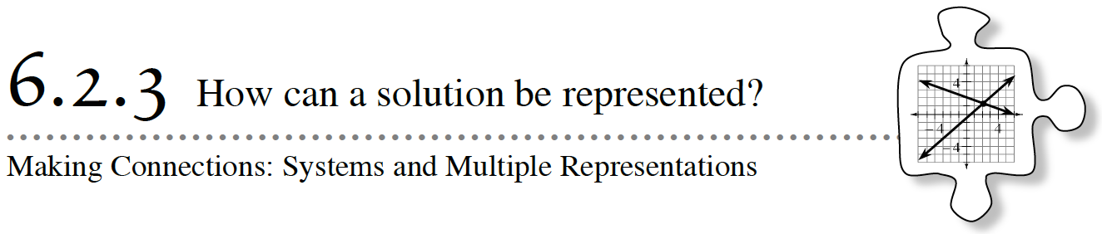
In this chapter you have practiced writing equations to represent situations. These situations often required you to solve a system of equations. So far, you can solve using either the Equal Values Method or the Substitution Method. Today you will also represent these situations on a graph and will more closely examine the solutions to two-variable equations.

6-67. THE HILLS ARE ALIVE
- The Alpine Music Club is going on its annual music trip. The members of the club are yodelers, and they like to play the xylophone. This year they are taking their xylophones on a gondola to give a performance at the top of Mount Monch.

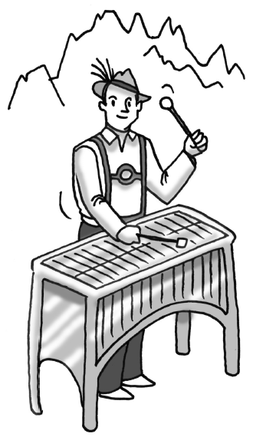
- The gondola conductor charges $2 for each yodeler and $1 for each xylophone. It costs $40 for the entire club, including the xylophones, to ride the gondola. Two yodelers can share a xylophone, so the number of yodelers on the gondola is twice the number of xylophones.
- How many yodelers and how many xylophones are on the gondola?

- Your Task:
  - Represent this problem with a system of equations.
  - Solve the system and explain how its solution relates to the yodelers on the music trip.
  - On the Resource Page, represent this problem with tables and a graph. Identify how the solution to this problem appears on the graph.
  - Answer each of the “Discussion Points” questions in your notebook.
What is a solution to a two-variable equation?
By themselves, how many solutions do each of the equations have? How are the solutions shown on the graph?
How does the solution to the system of equations appear on the graph?
How does the solution to the system of equations appear in the tables?
What is special about this point?
Why do you need to check the solution to a system of equations in both equations?

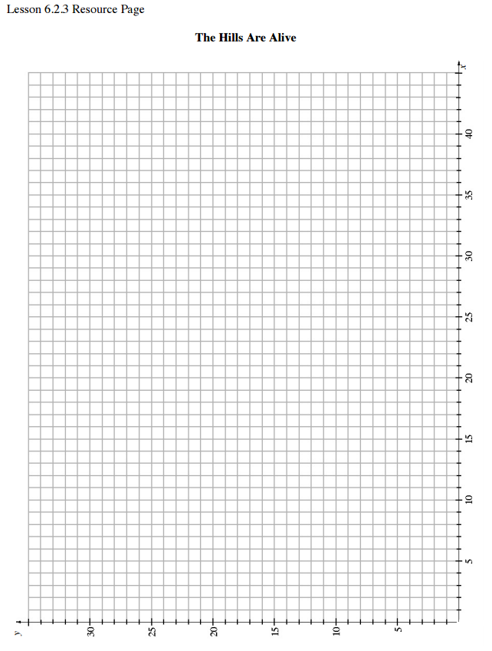
6-68. Start by focusing on one aspect of the problem: the cost to ride the gondola. The conductor charges $2 for each yodeler and $1 for each xylophone. It costs $40 for the entire club, with instruments, to ride the gondola.

  - Write an equation with two variables that represents this information. Be sure to define your variables.
  - Find a combination of xylophones and yodelers that will make your equation from part (a) true. Is this the only possible combination?

  - List five additional combinations of xylophones and yodelers that could ride the gondola if it costs $40 for the trip. With your team, decide on a good way to organize and share your list.

  - Jon says, “I think there could be 6 xylophones and 12 yodelers on the gondola.” Is he correct? Use the equation you have written to explain why or why not.

  - Helga says, “Each correct combination we found is a solution to our equation.” Is this true? Explain what it means for something to be a solution to a two-variable equation.

6-69. Now consider the other piece of information: The number of yodelers is twice the number of xylophones.

  - Write an equation that expresses this piece of information. Be sure to use your let statement from part (a) of problem 6-68.

  - List four different combinations of xylophones and yodelers that will make this equation true.

  - Put the equation you found in part (a) together with your equation from problem 6-68 and use substitution to solve this system of equations.

  - Is the answer you found in part (c) a solution to the first equation you wrote (the equation in part (a) of problem 6-68)? How can you check? Is it a solution to the second equation you wrote (the equation in part (a) of this problem)? Why is this a solution to the system of equations?

6-70. The solution to “The Hills are Alive” can also be represented graphically.

  - On graph paper, graph the equation you wrote in part (a) of problem 6-68. The points you listed for that equation may help. What is the shape of this graph? Label your graph with its equation.

  - Explain how each point on the graph represents a solution to the equation.

  - Now graph the equation you wrote in part (a) of problem 6‑69 on the same set of axes. The points you listed for that equation may help. Label this graph with its equation.

  - What are the coordinates of the point of intersection of the two lines? What is special about this point?

  - With your team, write as many ways as you can to express the solution to “The Hills are Alive” problem. Be prepared to share all the different forms you wrote for the solution with the class.
- 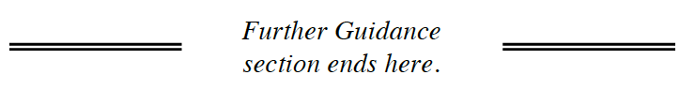

6-71. Look at your equations and graphs for 6-67.

  - Name the x- and y-intercepts for the line representing the cost.

  - Name the x- and y-intercepts for the line representing the possible numbers of yodelers and xylophones.

  - Where do the graphs intersect each other?

  - The words “intersect” and “intercept” look and sound a lot alike, but what do they mean? How are they alike? How are they different?

6-72. Intercepts and intersections are similar, but they are not exactly the same. How can you tell which one you are looking for? Read the situations below and decide if the graphical solution would best be represented as an intercept or an intersection. Be prepared to defend your decision. Note: You do not need to solve the problem!

  - A 5-gram candle on a birthday cake is lit. Two minutes after it is lit, the candle weighs 4.2 grams. How long will the candle burn?

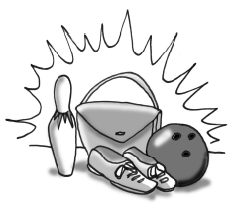
  - A local bowling alley charges you $4 to rent shoes and $3.50 for each game you play. Another alley charges you $7 to rent shoes and $2 for each game you play. How many games would you need to play in order for both alleys to charge you the same amount?

  - Two months after Aliya’s birthday, she had $450, while her sister Claudia had $630. Five months after her birthday, Aliya had $800, while Claudia had $920. How much did each person have on Aliya’s birthday?

The Substitution Method
The Substitution Method is a way to change two equations with two variables into one equation with one variable. It is convenient to use when one equation is already solved for a variable.
For example, to solve the system: | x = −3y + 1  4x − 3y = −11
Use substitution to rewrite the two equations as one. In other words, replace x in the second equation with (−3y + 1) from the first equation to get 4(−3y + 1) − 3y = −11. This equation can then be solved to find y. In this case, y = 1.  To determine the solution to the system, substitute the value you found into either original equation to calculate the other value.  In the example, substitute y = 1 into x = −3y + 1. Then write the answer for x and y as an ordered pair. |  | 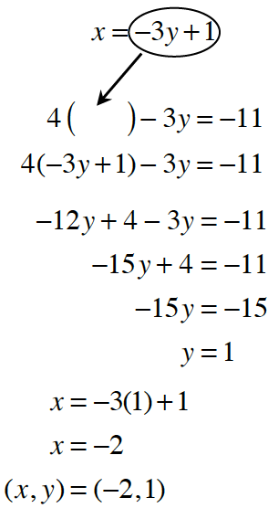
To check the solution, substitute x = −2 and y = 1 into both of the original equations. | 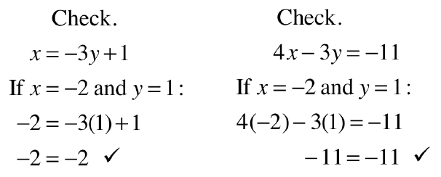

- Name________________________Per______
HOMEWORK ASSIGNMENT

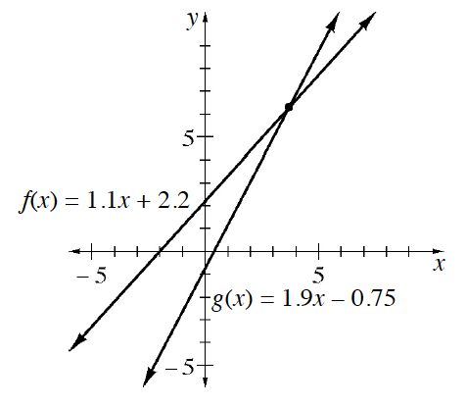
6-73. The graph at right shows the lines f(x) = 1.1x + 2.2 and
- g(x) = 1.9x – 0.75. One combination of input and output values will satisfy both functions. How do you know this? Use the graph to estimate this combination of values. Then create a table of values for each function and use it to justify your answer.

6-74. Hotdogs and corndogs were sold at last night’s football game. Use the information below to write equations to help you determine how many corndogs were sold.

  - The number of hotdogs sold was three fewer than twice the number of corndogs sold. Write an equation relating the number of hotdogs and corndogs. Let h represent the number of hotdogs and c represent the number of corndogs.

  - A hotdog costs $3 and a corndog costs $1.50. If $201 was collected, write an equation to represent this information.

  - How many corndogs were sold? Show how you calculated your answer.

6-75. Rianna thinks that if a = b and c = d, then a + c = b + d. Is she correct?

6-76. Solve the following equation for x, if possible. Check your solutions.

  - −(2 − 3x) + x = 9 – x b. 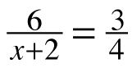

c. 5 − 2(x + 6) = 14 d.

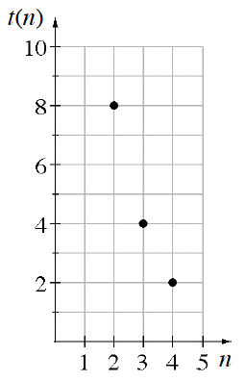
6-77. Write an explicit equation for the sequence graphed at right.

6-78. Serena wanted to examine the graphs of the equations below on her graphing calculator. Rewrite each of the equations in y = form (when the equation is solved for y) so that she can enter them into the calculator.

  - 5 −(y − 2) = 3x b. 5(x + y) = −2

- 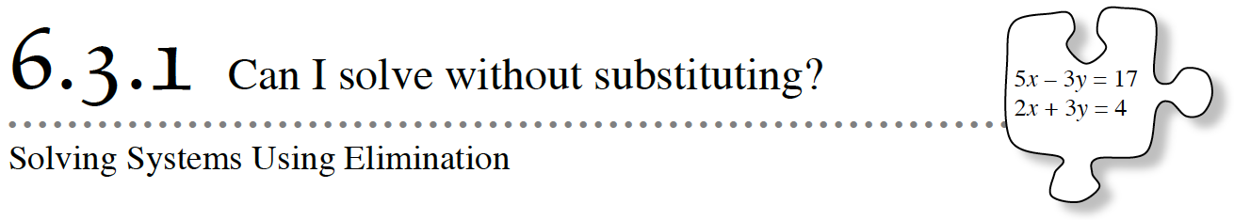
In this chapter, you have learned the Equal Values Method and the Substitution Method for solving systems of equations. But are these methods the best to use for all types of systems? Today you will develop a new time-saving method for solving a systems of linear equations when both equations are in standard form, ax + by = c.
6-79. Jeanette is trying to find the intersection point of these two lines:

  - 2x + 3y = −2
  - 5x − 3y = 16

She has decided to use substitution to find the point of intersection. Her plan is to solve the first equation for y, and then to substitute the result into the second equation. Use Jeanette’s idea to solve the system.

6-80. AVOIDING THE MESS: THE ELIMINATION METHOD

Your class will now discuss a new method, called the Elimination Method, to find the solution to Jeanette’s problem without the complications and fractions of the previous problem. Your class discussion is outlined below.

- a. Write Jeanette’s first equation on your paper:

2x + 3y = − 2

- b. Jeanette can add any expression she chooses to both sides of the equation. If she wanted to, she could choose to add 16 to both sides. You will see in a moment why that makes sense.

2x + 3y = −2
+16 +16

- Jeanette notices that 16 is equal to 5x − 3y, according to the second equation in problem 6-79.
- On the left side, instead of adding 16, Jeanette decides to add 5x − 3y.
- After all, 16 is equivalent to 5x − 3y.

2x + 3y = −2
+(5x − 3y) +16

Write a new equation for the result of Jeanette's addition to both sides of the equation. Notice that you now have only one equation with one variable. What happened to the y-terms? Solve this new equation for the remaining variable.
- 2x + 3y = −2
- +(5x − 3y) +16

Use your solution for x to solve for y. Check your solution in both of the original equations.
Now use the Elimination Method to solve the system of equations below for x and y. Check your solution.
2x − y = −2
−2x + 3y = 10

6-81. Pat was in a fishing competition at Lake Pisces. He caught some bass and some trout. Each bass weighed three pounds, and each trout weighed one pound. Pat caught a total of 30 pounds of fish. He got five points in the competition for each bass, but since trout are endangered in Lake Pisces, he lost one point for each trout. Pat scored a total of 42 points.

Write a system of equations representing the information in this problem.

Explain why this system is a good candidate for the Elimination Method.

Solve this system to find out how many bass and trout Pat caught. Be sure to record your work and check your solution.

6-82. ANNIE NEEDS YOUR HELP
Annie was going to use the Elimination Method. She was ready to add the same value to both sides of the equation to eliminate the x terms when she noticed a problem: Both x-terms are positive!

  - 2x + 7y = 13
  - 2x + 3y = 5

With your team, figure out something you could do that would allow you to add the value of the second equation to the first equation and eliminate the x-terms. Once you have figured out a method, solve the system and check your solution. Be ready to share your method with the class.

6-83. Solve each system of equations using the Elimination Method. Show your steps algebraically. Check each solution.

a. | 2y - x = 5  -3y + x = -9 | b. | 2x - 4y = 14  4y - x = -3 | c. | 3x + 4y = 1  2x + 4y = 2
d. | For each of the previous systems of equations, where do the graphs of each pair of lines intersect?

Systems of Linear Equations

A system of equations is a set of two or more linear equations that are given together, such as the example at right. | - y = 2x  - y = −3x + 5
To represent a system of equations graphically, you can simply graph each equation on the same set of axes. The lines may or may not have a point of intersection. The example at right has a point of intersection which is circled.  Also notice that the point of intersection lies on both graphs in the system of equations. This means that the point of intersection is a solution to both equations in the system. For example, the point of intersection of the two lines graphed above is (1, 2). This point of intersection makes both equations true, as shown at right. | 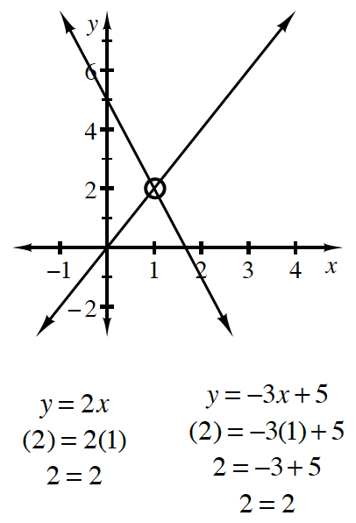

- Name________________________Per______
HOMEWORK ASSIGNMENT

6-84. What are the points of intersection of the lines below? Use any method. Write your solutions as a point (x, y).
2x − y = 10
y = −4x + 2
  - y = −x + 8 b.
y = x − 2

6-85. Jai was solving the system of equations below when something strange happened.

- y = −2x + 5
- 2y + 4x = 10

  - Solve the system. What happened?

c. How does your graph in part (b) explain your result in part (a)?

  - Graph the two lines on the same set of axes.
What happened?
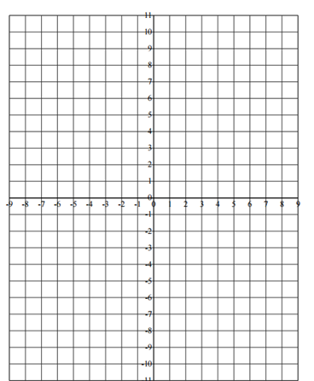
6-86. On Tuesday the cafeteria sold pizza slices and burritos. The number of pizza slices sold was 20 less than twice the number of burritos sold. Pizza sold for $2.50 a slice and burritos sold for $3.00 each. The cafeteria collected a total of $358 for selling these two items.

  - Write two equations with two variables to represent the information in this problem. Be sure to define your variables by writing let statements.

  - Solve your system from part (a). Then determine how many pizza slices were sold.

6-87. An item currently costing $20 is increasing in cost by 5% per year.

  - What is the multiplier?

  - What will the item cost five years from now?

  - Write an equation to calculate the cost in n years. What does each of the factors in your equation represent?

6-88. A train traveled 90 miles in 1.5 hours. At the same rate how long will it take the train to travel 330 miles.

  - Use proportions to solve and show your work with units.

  - Solve using d = rt.

  - Did you get the same solution?

6-89. Simplify each expression. In parts (c) and (d) write your answers using scientific notation.

  - 2³ · 5⁻² b. (xy²)³ · (x⁻²)

c. 3 × 10³ · 4 × 10⁵ d. 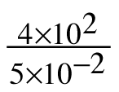

- 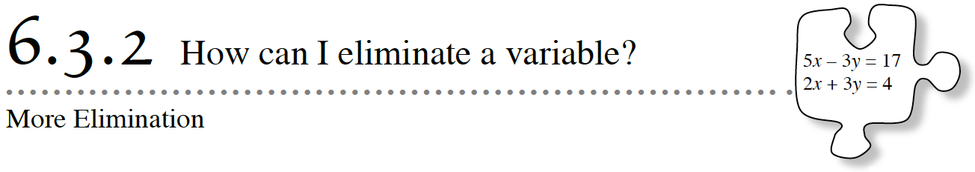
In Lesson 6.3.1, you learned how to use the Elimination Method to solve systems of equations. In this method, you combined two equations in a way that eliminated one of the variables. This method is particularly useful for solving systems of equations where both equations are in standard form.

6-90. Dragonflies and Fairies
Phoebe was helping her mom buy gifts for her little sister’s birthday party. There were 11 friends attending the party. Dragonfly wings for the boys cost $1 while the fairy wings for the girls cost $2. Phoebe’s mom spent $18 on the gifts. How many dragonfly wings and fairy wings did Phoebe’s mom purchase?
- Define variables for the problem.
- Set up two equations.
- Solve the system using the elimination method.

6-91. Rachel is trying to solve the system:
- Combine these equations. What happened?

- Is equivalent to ? That is, do they have the same solutions? Are their graphs the same? Justify your conclusion.

- Can be used instead of to help solve the system? If so, solve the system for x and y.

6-92. There are 21 animals on Farmer Cole’s farm – all sheep and chickens. If the animals have a total of 56 legs, how many of each type of animal lives on his farm?
- Define variables.
- Write two equations for the situation.
- Solve the system using the elimination method.

6-94. Solve each system below.
- Name________________________Per______
HOMEWORK ASSIGNMENT

6-95. Solve these systems of equations using any method. Check each solution, if possible.
a. 2x + 3y = 9  −3x + 3y = −6 | b. x = 8 − 2y  y − x = 4
c.  y = x − 8 | d. 9x + 10y = 14  7x + 5y = −3

6-96. Aimee thinks the solution to the system below is (−4, −6). Eric thinks the solution is (8, 2). Can they both be correct? Demonstrate that you know who is correct by showing your work for both possible solutions.
2x − 3y = 10
6y = 4x − 20

6-97. Matilda and Nancy are 60 miles apart, bicycling toward each other on the same road. Matilda rides 12 miles per hour and Nancy rides at 8 miles per hour. In how many hours will they meet?

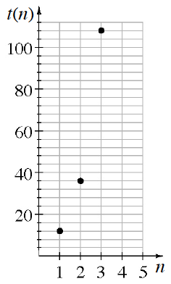

6-98. Write an explicit equation for the sequence based on the graph below.

6-99. Solve each equation for x. Graph your solution on a number line.

  - 10 − 2(2x + 1) = 4(x − 2) b. 5 − (2x − 3) = −8 + 2x

6-100. Solve each equation for the indicated variable.

  - y = mx + b (for b) b. y = mx + b (for x)

c. I = prt (for t) d. A = p + prt (for t)

- 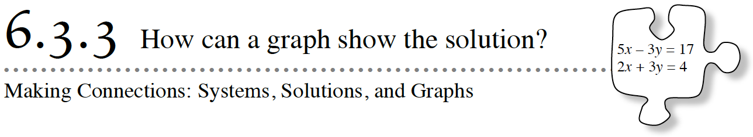
Today you will build on your previous work with the Elimination Method. You will also explore unique systems of equations by writing equations, using tables, and making graphs.

6-101. A NEW ELIMINATION CHALLENGE

- Carefully examine this system:

4x + 3y = 10
9x − 4y = 1
- With your team, propose a way to combine these equations so that you eventually have one equation with one variable. Be prepared to share your proposal with the class.

6-102. The art club at school is painting a mural using their school colors. Blue paint comes in a 5-ounce container costing $2 per container. The containers of silver paint hold two ounces and cost $3 per container. The art club spent $56 and bought a total of 74 ounces of paint. How many containers of blue paint and how many containers of silver paint did the art club buy?

6-103. Tracy’s team was given the following system by their teacher.

10x + 4y = −8
5x + 2y = 10

  - Use the Elimination Method to solve. What happened?
  - Do these two equations represent the same line? How can you tell?
  - If you have not done so already, write both equations in y = mx + b form. How can you explain the solution you got in part (a)?
6-104. The equations of two lines are given below. A table of solutions for the first equation has been started for you.
- 2y – 5x = 8  x y  -6 -11  -4 -6  -2 -1  0  2  4 | y = 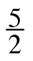x – 2  x y  -6  -4  -2  0  2  4
- Complete the tables for the given equations. Using the tables, can you readily find the point of intersection of these two lines?
b. Graph both lines. Without algebraically solving the system of equations, can you predict how
many solutions the system of equations has? Explain.
c. Solve the system algebraically. Was your prediction in part (a) correct?

6-105. The equations of two lines are given below. A table of solutions for the first equation has been started for you.
- 10x – 4y = 8  x y  -6 -17  -4 -12  -2 -7  0  2  4 | x y  -6  -4  -2  0  2  4
- Complete the tables for the given equations. Using only the tables, can you predict the solution to the system of equations?
- Graph both lines. Without algebraically solving the system of equations, can you predict how many solutions the system of equations has? Explain.
- When two lines are on top of each other, we say that the two lines coincide. Solve the system algebraically. What kind of algebraic solution do you get to a system of equations when the two lines coincide?

The Elimination Method
One method of solving systems of equations is the Elimination Method. This method involves adding both sides of two equations to eliminate a variable. Equations can be combined this way because balance is maintained when equal amounts are added to both sides of an equation. For example, if a = b and c = d, then if you add a and c you will get the same result as adding b and d. Thus, a + c = b + d.
The first step is to rewrite the equations so that the variables are lined up vertically. Next, decide what number to multiply each equation by, if necessary, in order to make the coefficients of either of the variables sum to zero. Be sure that you can justify each step in the solution.
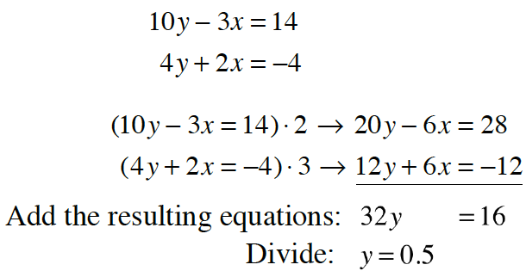
For example, consider the system at right.

You can eliminate the x-terms by multiplying the top equation by 2 and the bottom equation by 3 and then adding the equations, as shown at right.

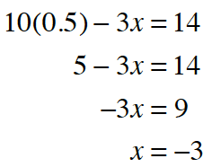
Finally, substitute 0.5 for y in either original equation:
Thus, the solution to the system is (−3, 0.5).
Check your solution in both of the original equations.

- Name________________________Per______
HOMEWORK ASSIGNMENT

6-106. Multiply the polynomials. That is, rewrite each product as a sum.

  - (2x + 1)(3x − 2) b. (2x + 1)(3x² − 2x − 5)

6-107. Determine the point of intersection of each pair of lines if one exists. Be sure to record your process on your paper. Check each solution, if possible.

- a. | - x = −2y − 3  - 4y − x = 9 | - b. | - x + 5y = 8  - −x + 2y = −1 | - c. | - 4x − 2y = 5  - y = 2x + 10
6-108. Examine the graphs below. Decide if each graph represents a function. Then describe the domain and range of each one.
- a. | - 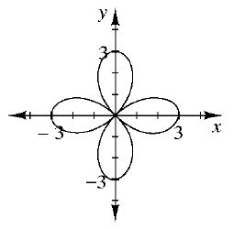 | - b. | - 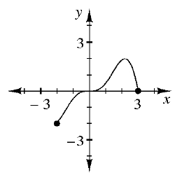
6-109. Make a conjecture about what r is for the following scatterplot. Make a conjecture about what the LSRL equation might be.
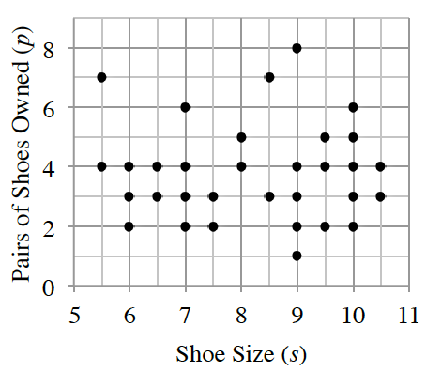
- ​

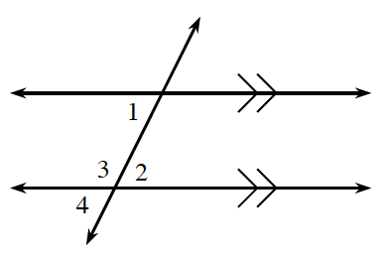
6-110. Refer to the diagram at right.

  - If m∠1 = 74º and m∠4 = 3x − 18º, write an equation and solve for x.
  - If m∠2 = 3x − 9º and m∠1 = x + 25º, write an equation and solve for x. Then determine m∠2.

6-111. This problem is the checkpoint for solving linear equations (with fractional coefficients). It will be referred to as Checkpoint 6A.
Solve each equation.
a. | $\frac{1}{6}m$ - 3 = -5 | b. | $\frac{2}{3}x$ - 3 = $\frac{1}{2}x$ - 7 | c. | x + $\frac{x}{2}$ - 4 = $\frac{x}{4}$

Check your answers by referring to the Checkpoint 6A materials located at the back of your book.
Ideally, at this point you are comfortable working with these types of problems and can solve them correctly. If you feel that you need more confidence when solving these types of problems, then review the Checkpoint 6A materials and try the practice problems provided. From this point on, you will be expected to do problems like these correctly and with confidence.

- 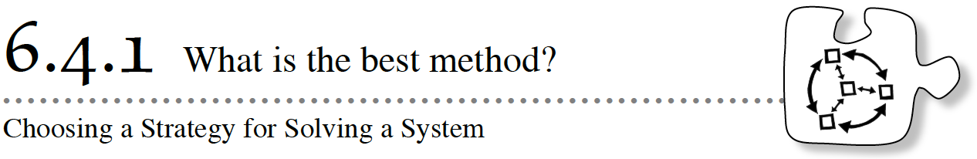
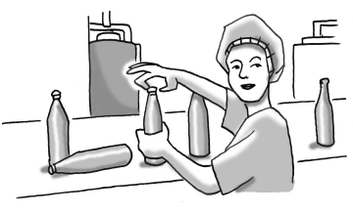
When you have a system of equations to solve, how do you know which method to use? Today you will focus on how to choose a strategy that is the most convenient and efficient for solving a system of equations.

6-112. Erica works in a soda-bottling factory. As bottles pass her on a conveyer belt, she puts caps on them. Unfortunately, Erica sometimes breaks a bottle before she can cap it. She gets paid 4¢ for each bottle she successfully caps, but her boss deducts 2¢ from her pay for each bottle she breaks.

Erica is having a bad morning. Fifteen bottles have come her way, but she has been breaking some and has only earned 6¢ so far today. How many bottles has Erica capped and how many has she broken?

  - Write a system of equations representing this situation.
  - Solve the system of equations using two different methods: substitution and elimination. Demonstrate that each method results in the same solution.

6-113. For each system below, decide which algebraic solving strategy to use. That is, which method would be the most efficient and convenient: the Substitution Method, the Elimination Method, or setting the equations equal to each other (the Equal Values method)? Do not solve the systems yet! Be prepared to justify your reasons for choosing one strategy over the others.

a. | x = 4 - 2y  3x - 2y = 4 | b. | 3x + y = 1  4x + y = 2
c. | x = - 5y + 2  x = 3y - 2 | d. | 2y - 4x = 10  2y + 6 = x
e. | d = 2(7 + w)  3d = 15(7 - w) | f. | - 6x + 2y = 76  3x - y = -38
g. | 5x + 3y = -6  2x - 9y = 18 | h. | x - 3 = y  2(x - 3) - y = 7
6-114. With your team, use the best strategy to solve each system in problem 6-113. Be sure to check your solution.

a. | x = 4 - 2y  3x - 2y = 4 | b. | 3x + y = 1  4x + y = 2
c. | x = - 5y + 2  x = 3y - 2 | d. | 2y - 4x = 10  2y + 6 = x
e. | d = 2(7 + w)  3d = 15(7 - w) | f. | - 6x + 2y = 76  3x - y = -38
g. | 5x + 3y = -6  2x - 9y = 18 | h. | x - 3 = y  2(x - 3) - y = 7

6-115. LEARNING LOG
- In your Learning Log, summarize everything you know about solving systems of equations. Include examples and explain each method. Title this entry “Solving Systems of Equations” and include today’s date.

Number of Solutions to a System of Equations
When two lines lie on the same flat surface (called a plane), they may intersect (cross each other) once, an infinite number of times, or never.
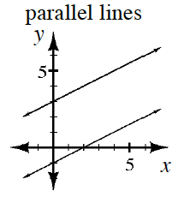For example, if the two lines are parallel, then they never intersect. The system of these two lines does not have a solution. Examine the graph of two parallel lines at right. Notice that they have the same slope but different y‑intercepts.
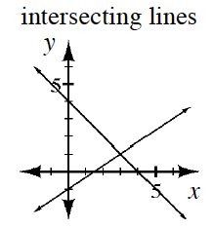If the two lines lie exactly on top of each other, we say that the two lines coincide. When you look at two lines that coincide, they appear to be one line. Since these two lines intersect each other at all points along the line, coinciding lines have an infinite number of intersections. The system has an infinite number of solutions. Both lines have the same slope and same y‑intercept.
The most common case for a system of equations is when the two lines intersect once, as shown at right. The system has one solution, namely, the point where the lines intersect, (x, y).

- Name________________________Per______
HOMEWORK ASSIGNMENT

6-116. Solve the following systems of equations using any method. Check each solution, if possible.
- a. | - a. −2x + 3y = 1  - 2x + 6y = 2 | - b. | - b. y = 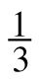x + 4  - x = −3y
- c. | - c. 3x − y = 7  - y = 3x − 2 | - d. | - d. x + 2y = 1  - 3x + 5y = 8
6-117. The Math Club is baking pies for a bake sale. The fruit-pie recipe calls for twice as many peaches as nectarines. If it takes a total of 168 pieces of fruit for all the pies, how many nectarines are needed?

6-118. Candice is solving this system:
2x − 1 = 3y
- 5(2x − 1) + y = 32

  - She notices that each equation contains the expression 2x − 1. Can she substitute 3y for 2x − 1? Why or why not?
  - Substitute 3y for 2x − 1 in the second equation to create one equation with one variable. Then solve for x and y.

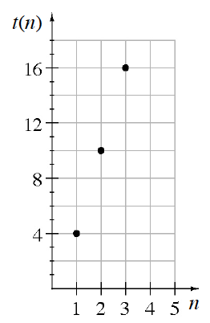
6-119. Write an explicit equation for the sequence based on the graph at right.

6-120. Write the equation of the line with a y-intercept of (0, 6) and an x-intercept of (4, 0).

6-121. This problem is a checkpoint for multiplying binomials and solving equations with parentheses. It will be referred to as Checkpoint 6B.
- In parts (a) and (b) rewrite the expression without parentheses, and in parts (c) and (d) solve each equation.
- a. | - a. 2x(x + 3) | - b. | - b. (3x + 2)(x − 3)
- c. | - c. 4y − 2(6 − y) = 6 | - d. | - d. x(2x − 4) = (2x + 1)(x − 2)
Check your answers by referring to the Checkpoint 6B materials located at the back of your book.
Ideally, at this point you are comfortable working with these types of problems and can solve them correctly. If you feel that you need more confidence when solving these types of problems, then review the Checkpoint 6B materials and try the practice problems provided. From this point on, you will be expected to do problems like these correctly and with confidence.
- 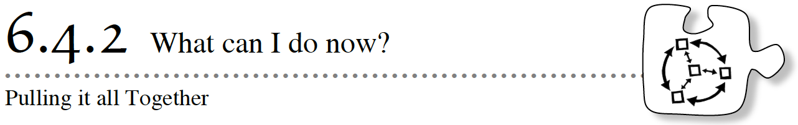
As you solve the problems below, remember to make connections between everything you know about linear equations and systems of linear equations. This lesson contains several problems that will require you to use the algebra content you have learned so far in new ways. If you get stuck, think of what the problem reminds you of. Decide if there is a different way to approach the problem. Most importantly, discuss your ideas with your team.

6-122. Brianna has been collecting insects and measuring the lengths of their legs and antennae. Below is the data she has collected so far.

 | Ant | Beetle | Grasshopper
Length of Antenna (x) | 2 mm | 6 mm | 20 mm
Length of Leg (y) | 4 mm | 10 mm | 31 mm
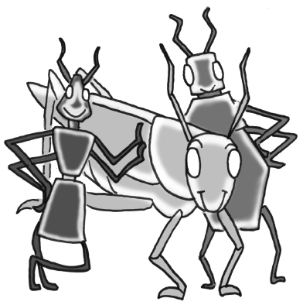
  - Graph the data Brianna has collected.
  - Brianna thinks that she has found an equation relating antenna length and leg length:
4y − 6x = 4. Could Brianna’s equation be correct? If not, write your own equation relating antenna length and leg length.
  - If a ladybug has an antenna 1 mm long, how long does Brianna’s equation predict its legs will be? Use both the equation and the graph to justify your answer.

6-123. One evening, Gemma saw three different phone company ads. TeleTalk boasted a flat rate of 8¢ per minute. AmeriCall charges 30¢ per voice call plus 5¢ per minute. CellTime charges 60¢ per voice call plus 3¢ per minute.

You are not sure how many minutes Gemma plans on using the phone for voice calls. Write a paragraph to Gemma explaining which plan she should use under various circumstances. Include multiple representations in your answer.

6-124. Without graphing, determine which of the following equations represent lines that are parallel to each other. Which represent perpendicular lines? Show how you know.
- a. | - a. −3x + y = 5 | - c. | - b. −5x + y = 3
- b. | - c. x + 5y = −15 | - d. | - d. −15x + 5y = −25

6-125. Mary Sue is very famous for her delicious brownies, which she sells at football games. The graph at right models the relationship between the number of brownies she sells and the amount of money she earns.

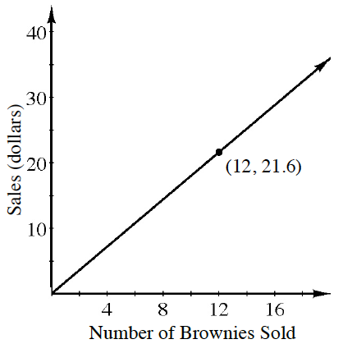
  - How much should she charge for ten brownies? Be sure to demonstrate your reasoning.

  - Is this a proportional relationship? Why or why not?
  - During the last football game, Mary Sue earned $34.20. How many brownies did she sell? Write an equation and show your work to solve it.

  - What is the unit rate of change in this situation?
6-126. A cruise ship left the Bahamas three hours before a private yacht. The vessels traveled in the same direction. The cruise ship traveled 25 miles per hour. The private yacht traveled at 40 miles per hour. At what distance from the Bahamas will the yacht overtake the cruise ship?

6-127. Solve each of the following equations for the indicated variable. Be sure to record your work.
- a. | - a. Solve for x: y = −2x + 5 | - b. | - b. Solve for p: m = 7 − 3(p − m)
- c. | - c. Solve for y: 2(y − 3) = 4 | - d. | - d. Solve for q: 4(q − 8) = 7q + 5
6-128. A superhero has been called to rescue the planet from destruction. He leaves from a point on the equator, and flies along the equator, at 60,000 m/min. At the same time, his partner flies from the same location in the opposite direction at 4415 km/h.

  - How long does it take for the two superheroes to fly along the equator and meet up? The circumference of the Earth is about 40,075 km.
  - How far does each superhero fly?

6-129. Anthony has the equations of three lines: A, B, and C. When he solves a system with equations A and B, he gets no solution. When he solves a system with equations B and C, he gets infinite solutions. What solution will he get when he solves a system with equations A and C? Justify your conclusion.

6-130. At Hector’s company, the longer you have worked for the company, the higher your hourly wage. Hector surveyed the people at his company and placed his data in the table below.

Number of Years at Company | 1 | 3 | 6 | 7
Hourly Wage | $7.00 | $8.50 | $10.75 | $11.50

  - How much can Hector expect to make after working at the company for 5 years?

  - Is this a proportional situation?
  - Hector’s company is hiring a new employee who will work 20 hours a week. How much do you expect the new employee to earn during the first week?

- 6-131. When put on a coordinate plane, the center of the city is at (0, 0). Main Street had the equation y = 5x − 3. Park Street is parallel to Main Street and goes through the city center. Broadway is perpendicular to Main Street and has an ice cream shop five blocks north and five blocks east of city center. Write one equation for Park Street and one equation for Broadway.

- 6-132. Solve the problem below using two different methods.
- The Math Club sold roses and tulips this year for Valentine’s Day. The number of roses sold was eight more than four times the number of tulips sold. Tulips were sold for $2 each and roses for $5 each. The club made $414.00. How many roses were sold?

- 6-133. Lee’s model airplane flies at 18 miles per hour. Lee took the plane to a field in windy weather. It took six minutes to fly 2.2 miles with the wind. How fast was the wind blowing?

- Name________________________Per______
HOMEWORK ASSIGNMENT

6-134. What is the point of intersection of the graph of each set of equations below? Use any method and show your work. Check your solutions, if possible.

- a. 6x − 2y = 10  - 3x − 5 = y | - b. 6x − 2y = 5  - 3x + 2y = −2
- c. 5 − y = 3x  - y = 2x | - d. y = 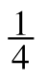x + 5  - y = 2x − 9
6-135. Consider the equation −6x = 4 − 2y.

  - If you graphed this equation, what shape would the graph have? How can you tell?
  - Without changing the form of the equation, find the coordinates of three points that must be on the graph of this equation. Then graph the equation on graph paper.

  - Solve the equation for y. Does your answer agree with your graph? If so, how do they agree? If not, check your work to find the error.
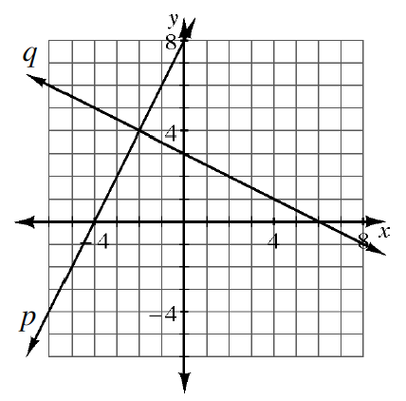
6-136. The graphs of two equations are shown at right.

  - Write an equation for each line.

  - Does x = −2 and y = 4 solve both of the equations you wrote in part (a) above? How can you tell without actually checking the solution in the equations?

  - What is the relationship between the two lines in part (a)? How do you know?

  - Solve the system of equations you wrote in part (a) algebraically. Verify that your solution matches the one shown in the graph.

6-137. For the recursively defined sequence: a₁ = 5
- a_{n} = −2 · a_{n−1}

  - List the first five terms of the sequence.
  - Write an explicit equation for the sequence.

6-138. By drawing and labeling an area model or by using the Distributive Property, what are each of the following products? Show the method you use.
  - (x + 5)(x + 4) b. 2y(y​ + 3)

- 6-139. Plot ΔMJN on graph paper with points M(3, 3), J(1, 1), and N(6, 1).
  - Rotate the triangle 90º counterclockwise (↺) about the origin. Name the coordinates of ΔM′J′N′.
  - Next, reflect ΔM′J′N′ across the y-axis. Name the coordinates of M″J″N″.
  - What is the area of ΔMJN?

- 6-140. Thirty coins, all dimes and nickels, are worth $2.60. How many nickels are there?

- 6-141. Multiple Choice: Which equation below could represent a tile pattern that grows by adding three tiles and has nine tiles in Figure 2?

  - 3x + y = 3
  - −3x + y = 9
  - −3x + y = 3
  - 2x + 3y = 9

6-142. Solve the systems of equations below using the method of your choice. Check your solutions, if possible.

  - y = 7 − 2x b. 3y − 1 = x
2x + y = 10 4x − 2y = 16

6-143. Solve each equation below for the indicated variable. Show all steps.

  - Solve for x: 2x + 22 = 12
  - Solve for y: 2x − y = 3
  - Solve for x: 2x + 15 = 2x − 15
  - Solve for y: 6x + 2y = 10

6-144. The current cost of a 55-inch HDTV is $1500 and decreasing by 15% per year.

  - What is the multiplier?
  - What will a 55-inch HDTV cost in four years?
  - Write an equation to calculate the cost in n years. What does each of the factors in your equation represent?

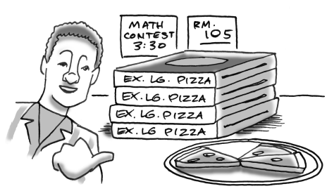
6-145. After the math contest, Basil noticed that there were four extra-large pizzas that were left untouched. In addition, another three slices of pizza were uneaten. If there were a total of 51 slices of pizza left, how many slices does an extra-large pizza have?

- 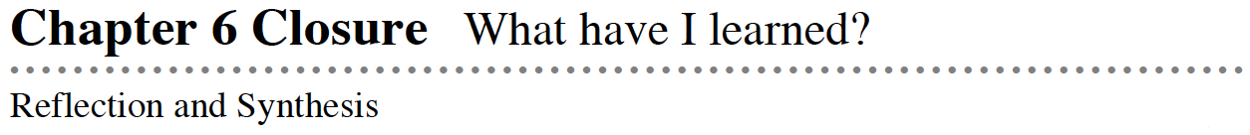

The activities below offer you a chance to reflect on what you have learned during this chapter. As you work, look for concepts that you feel very comfortable with, ideas that you would like to learn more about, and topics that you need more help with. Look for connections between ideas as well as connections to material you learned previously.

1. TEAM BRAINSTORM
- What have you studied in this chapter? What ideas were important in what you learned? With your team, brainstorm a list. Add as much detail as you can. To help get you started, Learning Log entries and Math Notes boxes are listed below.

- What topics, ideas, and words that you learned before this chapter are connected to the new ideas in this chapter? Again, write down as many details as you can.

- How long can you make your list? Challenge yourselves. Be prepared to share your team’s ideas with the class.
- Learning Log Entries
  - Lesson 6.1.2 – Solving Equations
  - Lesson 6.4.1 – Solving Systems of Equations
- Math Notes
  - Lesson 6.1.1 – Forms of a Linear Function
  - Lesson 6.2.1 – The Equal Values Method
  - Lesson 6.2.3 – The Substitution Method
  - Lesson 6.3.1 – Systems of Linear Equations
  - Lesson 6.3.3 – The Elimination Method
  - Lesson 6.4.1 – Number of Solutions to a System of Equations

2. MAKING CONNECTIONS
- Below is a list of the vocabulary words used in this chapter. Make sure that you are familiar with all of these terms and know what they mean. Refer to the glossary or index for any words that you do not yet understand.
- coincide | - Elimination Method | - Equal Values Method
- graph | - infinite solutions | - let statement
- mathematical sentence | - model | - multi-variable equation
- no solution | - parallel lines | - point of intersection
- situation | - solution | - standard form
- Substitution Method | - system of equations | - x y table
- y=mx+b
Make a concept map showing all of the connections you can find among the key words and ideas listed above. To show a connection between two words, draw a line between them and explain the connection, as shown in the model below. A word can be connected to any other word as long as you can justify the connection. For each key word or idea, provide an example or sketch that shows the idea.
- 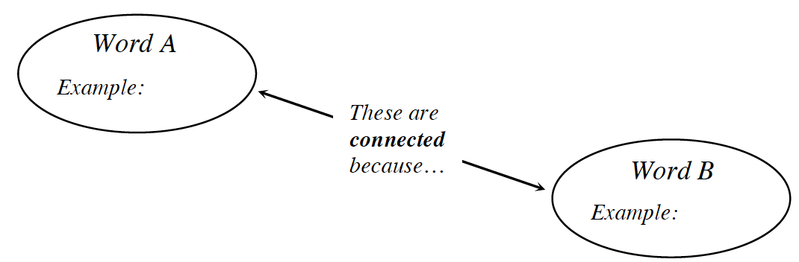
Your teacher may provide you with vocabulary cards to help you get started. If you use the cards to plan your concept map, be sure either to re-draw your concept map on your paper or to glue the vocabulary cards to a poster with all the connections explained for others to see and understand.
While you are making your map, your team may think of related words or ideas that are not listed here. Be sure to include these ideas on your concept map.

3. PORTFOLIO: EVIDENCE OF MATHEMATICAL PROFICIENCY
- Your teacher may have assigned some or all of the problems from Lesson 6.4.2 as portfolio entries. Make sense of the problems by making connections between all the topics you have studied in Chapters 1 through 6 and in previous courses. Show all of your work, explain your reasoning, and make viable arguments for your answers. Pay attention to precision.
- Alternatively, your teacher may ask you to include all of your work from problem 6‑112. Obtain the Chapter 6 Closure Resource Page: Systems of Equations Graphic Organizer from your teacher and complete it for problem 6‑112. Then include your work for problems 6‑113 and 6‑114. Justify your reasons for choosing one strategy over the others. Show all of your work and be sure to check your solutions.

4. WHAT HAVE I LEARNED?
- Most of the problems in this section represent typical problems found in this chapter. They serve as a gauge for you. You can use them to determine which types of problems you can do well and which types of problems require further study and practice. Even if your teacher does not assign this section, it is a good idea to try these problems and find out for yourself what you know and what you still need to work on.
- Solve each problem as completely as you can. The table at the end of the closure section has answers to these problems. It also tells you where you can find additional help and practice with problems like these.

CL 6-146. Solve these systems of equations using any method.

  - y = 3x + 7
y = −4x + 21
  - 3x − y = 17
−x + y = −7
  - x = 3y − 5
2x + 12y = −4

CL 6-147. Bob climbed down a ladder from his roof, while Roy climbed up another ladder next to Bob’s ladder. Each ladder had 30 rungs. Their friend Jill recorded the following information about Bob and Roy:

Bob went down two rungs every second.
Roy went up one rung every second.

- At some point, Bob and Roy were at the same height. Which rung were they on?

CL 6-148. Solve for x.

  - 6x − 11 = 4x + 12 b. 2(3x −5) = 6x − 4
c. (x − 3)(x + 4) = x² + 4 d.

e. 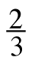x + 3 = x – 7 f. x + = 4

CL 6-149. Solve each equation for the indicated variable.

  - t = an + b (for b) b.

c. F = ma (for m) d. F = ma (for a)

CL 6-150. Leo solved a system of equations by graphing. His graph is shown below.

  - Estimate the solution from the graph
  - What is the equation of each line in the system?
  - Solve the system algebraically. How accurate was your estimate?

CL 6-151. As treasurer of his school’s FFA club, Kenny wants to buy gifts for all 18 members. He can buy t-shirts for $9 and sweatshirts for $15. The club has only $180 to spend. If Kenny wants to spend all of the club’s money, how many of each type of gift can he buy?

  - Write a system of equations representing this problem.
  - Solve your system of equations and figure out how many of each type of gift Kenny should buy.

CL 6-152. Use the graph at right to complete parts (a) through (c) below.
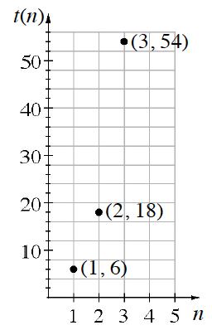
  - What is the multiplier for this sequence?
  - Write an explicit equation for this sequence.
  - Write a recursive equation for this sequence.

CL 6-153. In 2012 the average cost for a new midsized car was about $31,000.
- New car prices tend to go up about 2% every year.

  - What is the multiplier for this situation?

  - If this trend continues, what will the cost be in 4 years?

  - Write an equation to calculate the cost in n years. What does each of the factors in your equation represent?

CL 6-154. Check your answers using the table at the end of the closure section. Which problems do you feel confident about? Which problems made you think? Use the table to make a list of topics you need help on and a list of topics you need to practice more.

Answers and Support for Closure Activity #4

Problem | - Solution | - Need Help? | - More Practice
CL 6-146. | - a. x = 2, y = 13  - b. x = 5, y = –2  - c. x = –4, y = | Sections 6.2, 6.3, and 6.4  MN: 6.2.1, 6.2.3, 6.3.1, and 6.3.3  LL: 6.1.2 and 6.4.1 | Problems 6-64, 6‑84, 6‑95, 6‑107, 6‑116,6‑134, and 6‑142
CL 6-147. | - They were on the 10th rung. | Review from a previous course and Lesson 6.1.4  MN: 6.2.1  LL: 6.4.1 | Problems 5-25, 5‑55, 5‑82, 6‑25, and6-33
CL 6-148. | - a. x = 11.5  - b. no solution  - c. x = 16  - d. x = 17.5  - e. x = –24  - f. x = 3 | Section 3.3  Checkpoint 6A  Checkpoint 6B  - MN: 3.3.2 and 3.3.3 | Problems CL 3-142, CL 4‑109, CL 4-110,CL 5‑128, 6‑16, 6‑26, 6‑76, and 6‑111
CL 6-149. | - a. b = t − an  - b. y = 3(b + a)  - c. m = 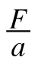  - d. a = 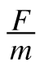 | Lessons 6.1.1 and 6.1.2  LL: 6.1.2 | Problems 6-7, 6-15, 6‑51, 6‑100, 6-127, and 6‑143
CL 6-150. | - a. Answers vary.  - b. y = –2x + 5 and y = x + 1  - c. 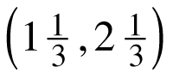 | Section 6.2  MN: 6.3.1 and 6.4.1  LL: 6.4.1 | Problems 6‑27, 6-73, 6‑84, 6‑134, and6‑136
CL 6-151. | - a. 9x + 15y = 180, x + y = 18  - b. 15 t-shirts, 3 sweatshirts | Chapter 6  MN: 6.3.3  LL: 6.4.1 | Problems 6‑61, 6-74, 6‑86, 6‑117, and6‑140
CL 6-152. | - a. 3  - b. a_{n} = t(n) 2 · 3^{n}  - c. a₁ = 2, a_{n+1} = 3 · a_{n} | Lessons 5.1.1, 5.2.3, and 5.3.1  MN: 5.3.2 and 5.3.3  LL: 5.3.2 | Problems CL 5-127, CL 5-130, 6-63,6-77, 6‑98, and 6-144
CL 6-153. | - a. 1.02  - b. $31,000 · 1.02⁴ = $33,555  - c. t(n) = 31,000 · 1.02^{n}  - 31,000 represents the cost of the car when it was new. 1.02 represents the 2% increase in cost. | Lesson 5.3.2  LL: 5.1.3 and 5.3.2 | Problems 5-102, 6-87, and 6-144

Review Preview Answers
6.1.1

6.1.2

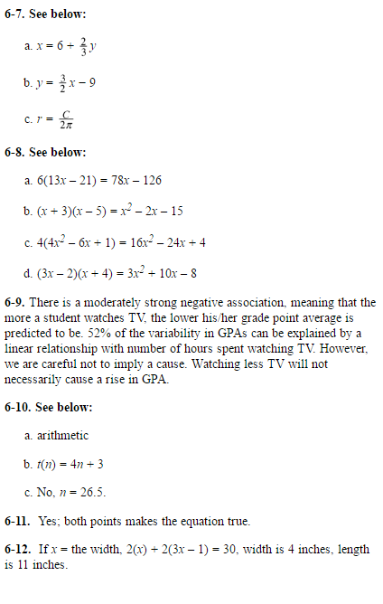
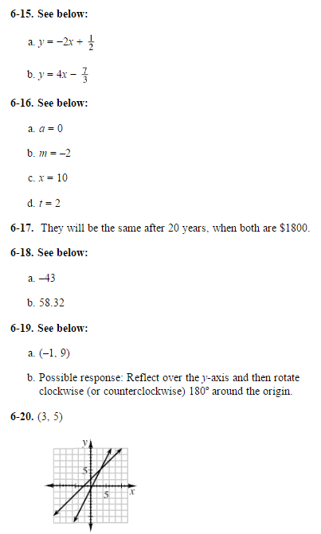

6.2.1
6.1.3
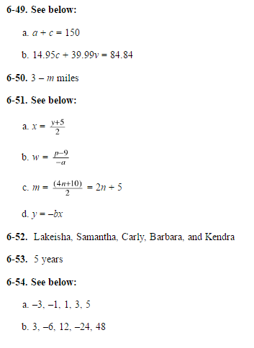
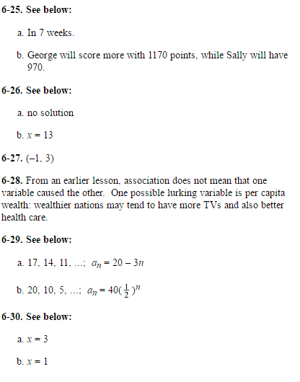

6.1.4

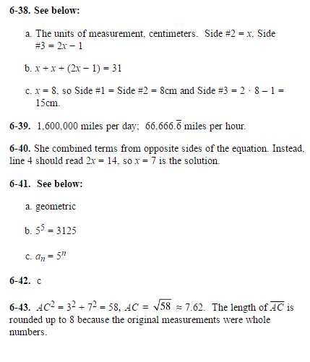

6.2.3
6.2.2
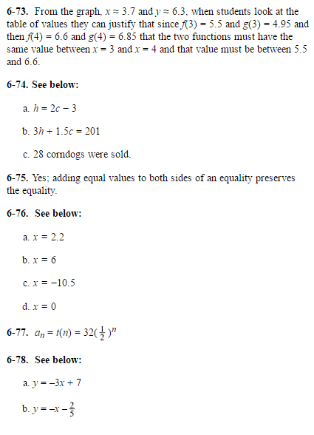
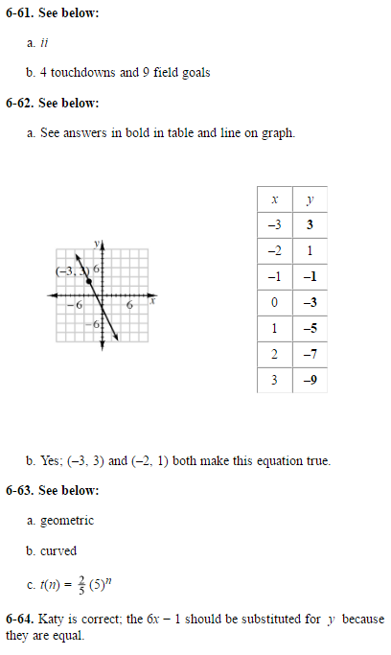

9.3.1

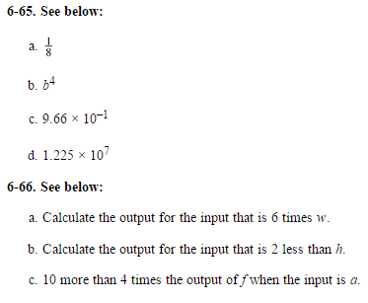

6.3.2
6.3.1

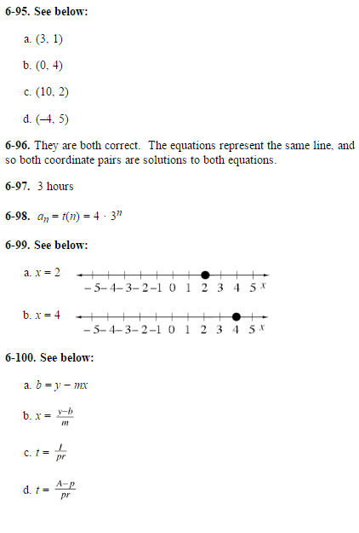
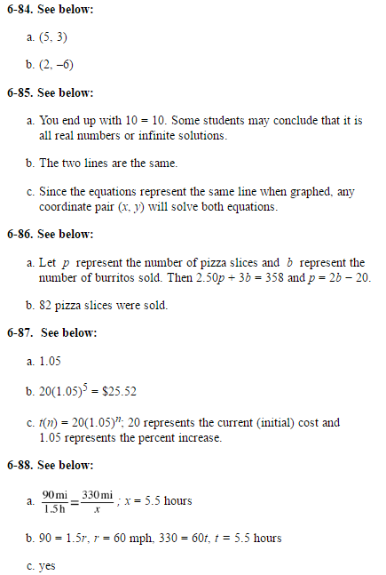

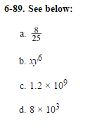

6.4.1
6.3.3

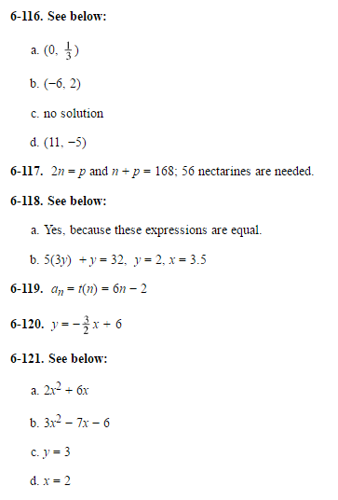
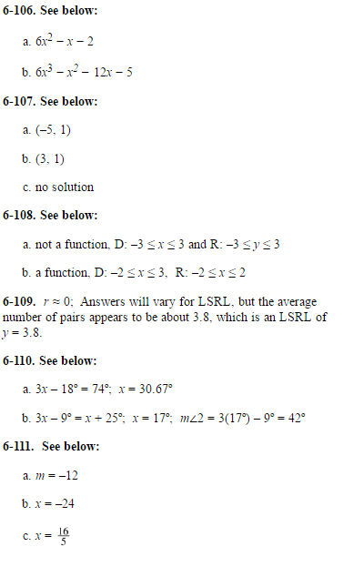

6.4.2

