**Equation Week**

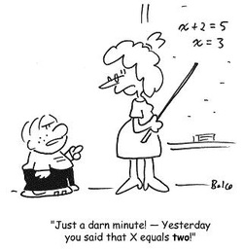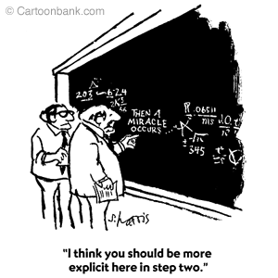



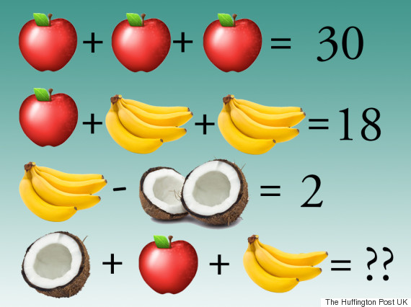

Day 1 Around the World

|  |  |
| --- | --- |
| 1 | 2 |
| 3 | 4 |
| 5 | 6 |
| 7 | 8 |
| 9 | 10 |

Equation Week Bingo

|  |  |  |  |  |
| --- | --- | --- | --- | --- |
|  |  |  |  |  |
|  |  |  |  |  |
|  |  |  |  |  |
|  |  |  |  |  |
|  |  |  |  |  |

Equation Week Scavenger Hunt

|  |  |  |  |  |  |
| --- | --- | --- | --- | --- | --- |
| Location or person | Show your work | Answer | Location or person | Show your work | Answer |
| Math Teacher |  |  | Mr. Schindler  Principal |  |  |
| Math Lab |  |  | Performing Arts Center  Display case |  |  |
| An AVID teacher |  |  | Marquee |  |  |
| Location or person | Show your work | Answer | Location or person | Show your work | Answer |
| Career Center |  |  | Student Store |  |  |
| Mrs. Barnes  Assistant Principal |  |  | Mrs. Golly  Assistant  Principal |  |  |
| Mrs. Hermansen  Assistant Principal |  |  | Mr. Loza  Assistant Principal |  |  |

|  |  |  |  |  |  |
| --- | --- | --- | --- | --- | --- |
|  | Solving Equations | Integers | More Solving | Crazy! | Literal Equations |
| **100** |  |  |  |  |  |
| **200** |  |  |  |  |  |
| **300** |  |  |  |  |  |
| **400** |  |  |  |  |  |
| **500** |  |  |  |  |  |



Equation Week HW #1 Name:____________________ Per:___

|  |  |  |
| --- | --- | --- |
| 1. | 2. | 3. |
| 4. | 5. | 6. |
| 7. 5x + 3(x + 1) = 12 | 8. 6(c + 2) + 1 = 7 | 9. 15 = 2(x + 3) – 5 |
| 10. | 11. | 12. |
| 13. | 14. | 15. |
| 16. | 17. | 18. |

Equation Week HW #2 Name:____________________ Per:___

|  |  |  |
| --- | --- | --- |
| 1. | 2. | 3. |
| 4. | 5. | 6. |
| 7. | 8. | 9. |

Equation Week HW #3 Name:____________________ Per:___

Solve for y in problems 1-9

|  |  |  |
| --- | --- | --- |
| 1. | 2. | 3. |
| 4. | 5. | 6. |
| 7. | 8. | 9. |